# Introduction to the Algoma OHT



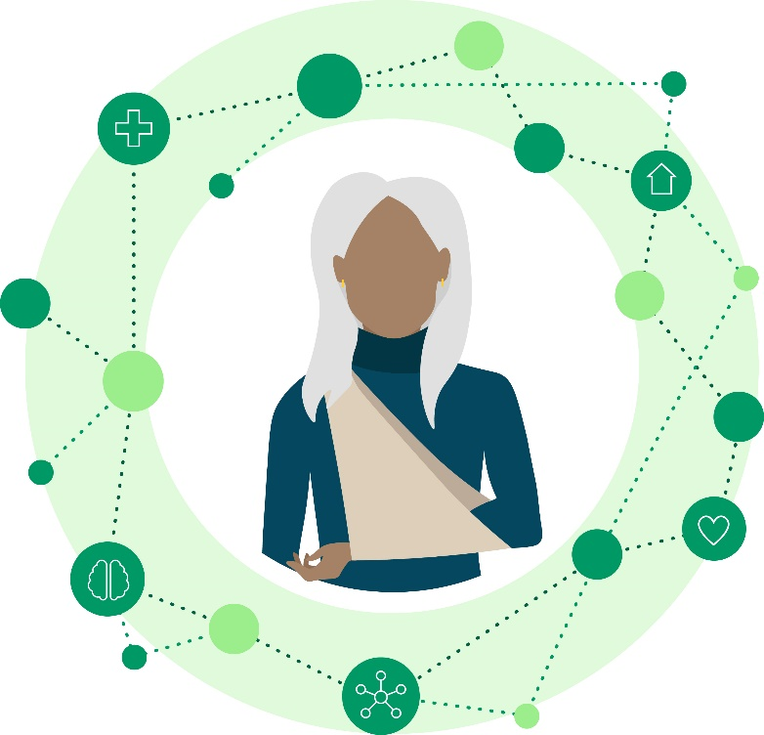The Algoma Ontario Health Team (AOHT) was officially formed in 2020. We’re a team of local health professionals, organizations, and community members working together to improve the health system in Algoma. We want to create a network where patients will have access to the right care, right team, and right care setting when they need it. To do this, we tackle big questions like, “how can we improve transitions in care?”, “how can we reduce gaps in care?”, “how can we integrate digital health solutions?”.

## What is an Ontario Health Team (OHT)?

The AOHT is one of 50 Ontario Health Teams (OHTs) across Ontario. OHTs are a new way of organizing and delivering care that is more connected to local communities. As part of an OHT, health care providers (including hospitals, doctors, and home and community care) and social service providers work as one coordinated team - no matter where they provide care.

***The Algoma OHT is a team of local health professionals, organizations, and community members working together to improve the health system in Algoma.***

|  |  |
| --- | --- |
| Vision | Mission |
| An integrated health system focused on the unique needs of Algoma residents, where people receive seamless, effective care where and when they need it. | The Algoma OHT will collaborate in a model of care that is person-centred, efficient, and simplified for both individuals and providers. |

## Who is Part of the Algoma OHT?

The Algoma OHT currently includes 15 organizational partners:

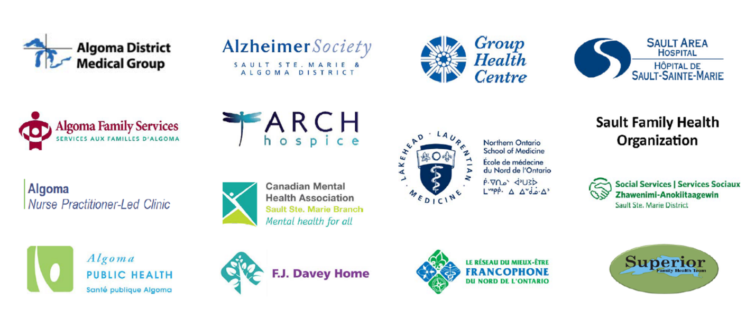

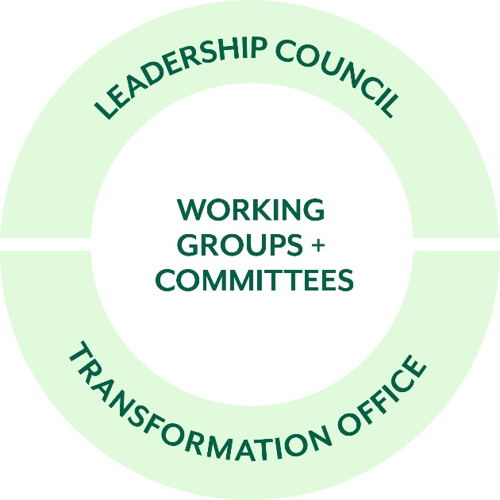We are led by the **Leadership Council** and supported by the **Transformation Office**. Our 17-member Leadership Council includes leaders from our partner organizations, community members, and clinicians. The council is responsible for strategic oversight, key decision-making, and priority setting. Our Transformation Office is a small group of staff that are dedicated to OHT activities. They support decision-making, project management and operations, communications, analytics, research, and community engagement.

It’s important to remember that the Algoma OHT is not a single set of employees – we are a network of people and organizations working together as one large team to make big, system-level changes. In addition to our core partners, our team works with more than 20 other organizations across Ontario.

## Projects you may Contribute to:

* **Community Wellness Bus:** The CWB works to improve health and social care coordination and transitions in the community for underserved individuals with unmet mental health and addictions needs. The bus visits a different location each day to provide services.

## What is Integrated Care?

Across Ontario Health Teams, you will often hear the term “integrated care”. Essentially, we are all striving to provide care that is “integrated”, or connected/linked/coordinated across many different people/organizations/sectors.

For our team, integrated care means coordinating efforts across health and social service organizations to improve the experience of Algoma residents. For community members, this means receiving connected care from one large team, regardless of where services and resources are accessed.

* **Healthy Aging:** This group leads initiatives designed to improve health and care for Algoma’s older adults.
* **Post Discharge Follow Up:** This short term group is working to measure and improve follow up from primary care after a patient is discharged from the hospital.
* **Caregiver ID**: This program formally recognizes caregivers as essential partners in care.
* **Digital Health:** This committee is developing a plan to guide our digital priorities in the upcoming years with an aim to improve patient access and experience.
* **Performance Measurement:** This group works to measure our progress as a team.